**Spring Boot Project**

**Step-1**

**A. Create Folders in D: drive**

**I. STS Editor**

**II. Spring Boot Projects**

**B. Create Folders in E: drive**

**I. Spring Boot Projects**

**Step-2**

**open chrome browser type below link**

<https://spring.io/tools3/sts/all>

**and observe the web page check version and download (windows version) zip file.**

**Step-3**

**open chrome browser type below text**

**github.com/javamahendra/MahindraApp**

**download zip file.**

**Step-4**

**download sts zip file copy, and paste on D: drive under STS Editor, Extract zip file.**

**MahindraApp project zip file copy and paste on D: driver under Spring Boot Projects, Extract zip file.**

**STS zip file extact after see below pic-1**

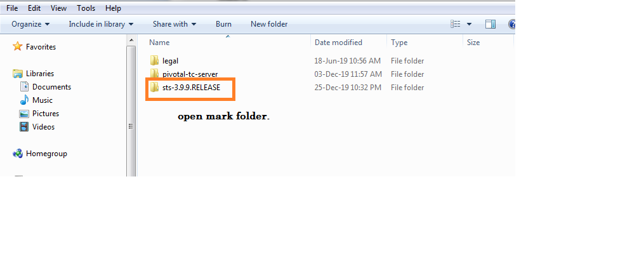

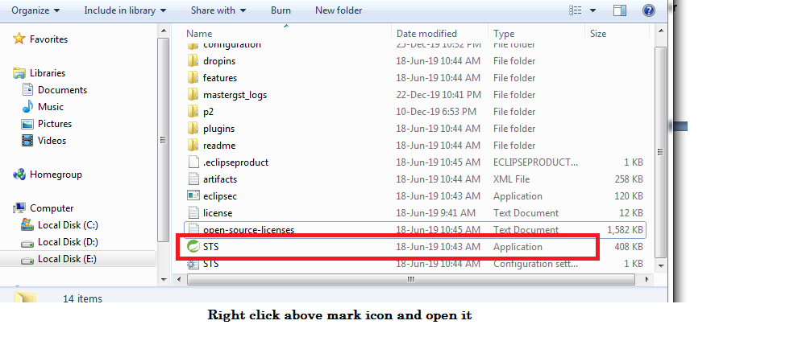

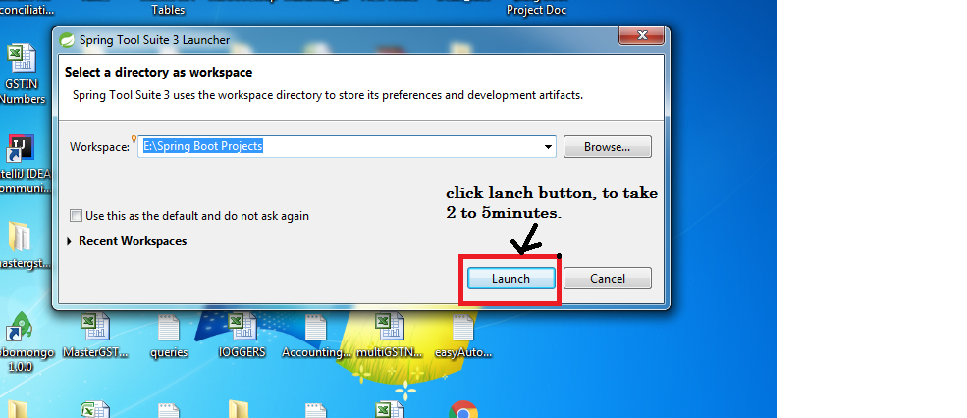

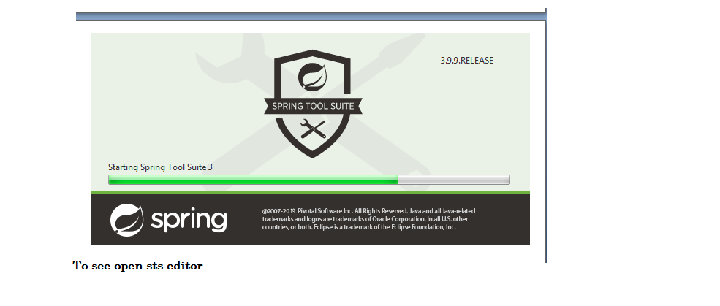

**STS Open and after**

**To see Left Hand Side Top File menu click ,**

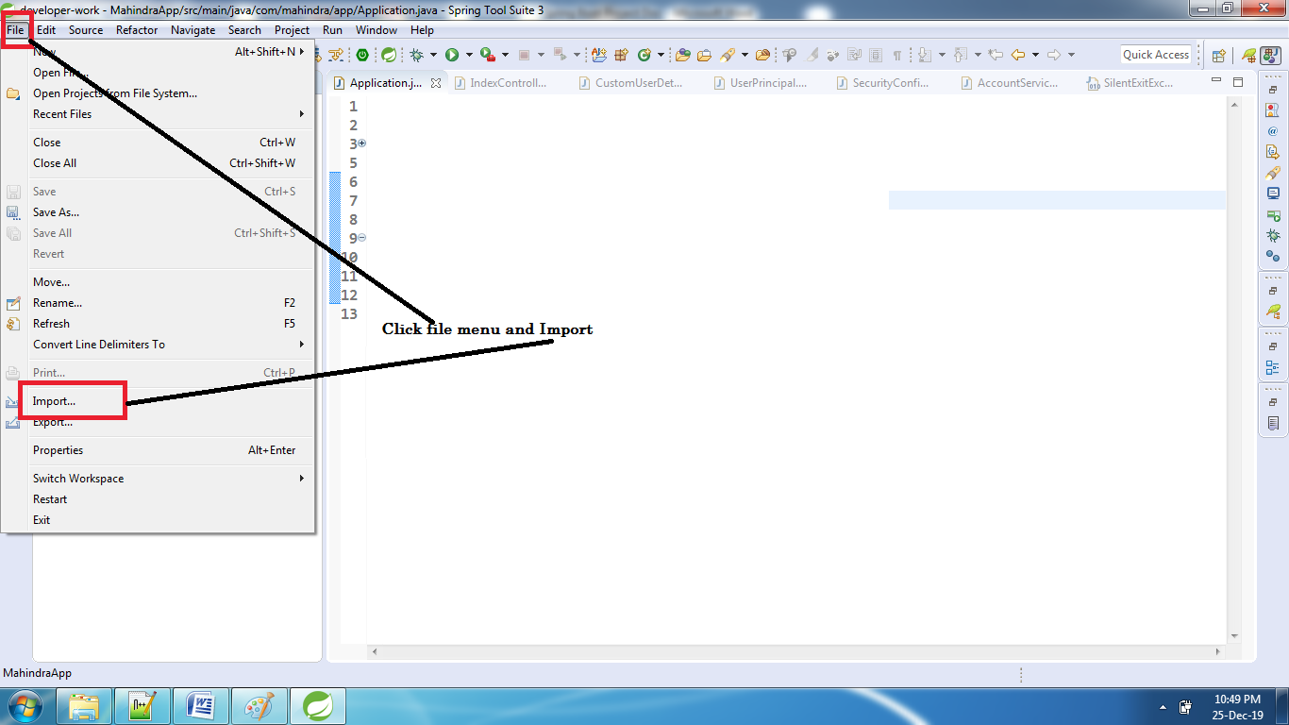

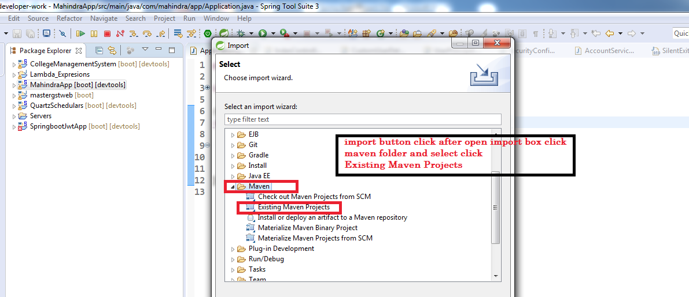

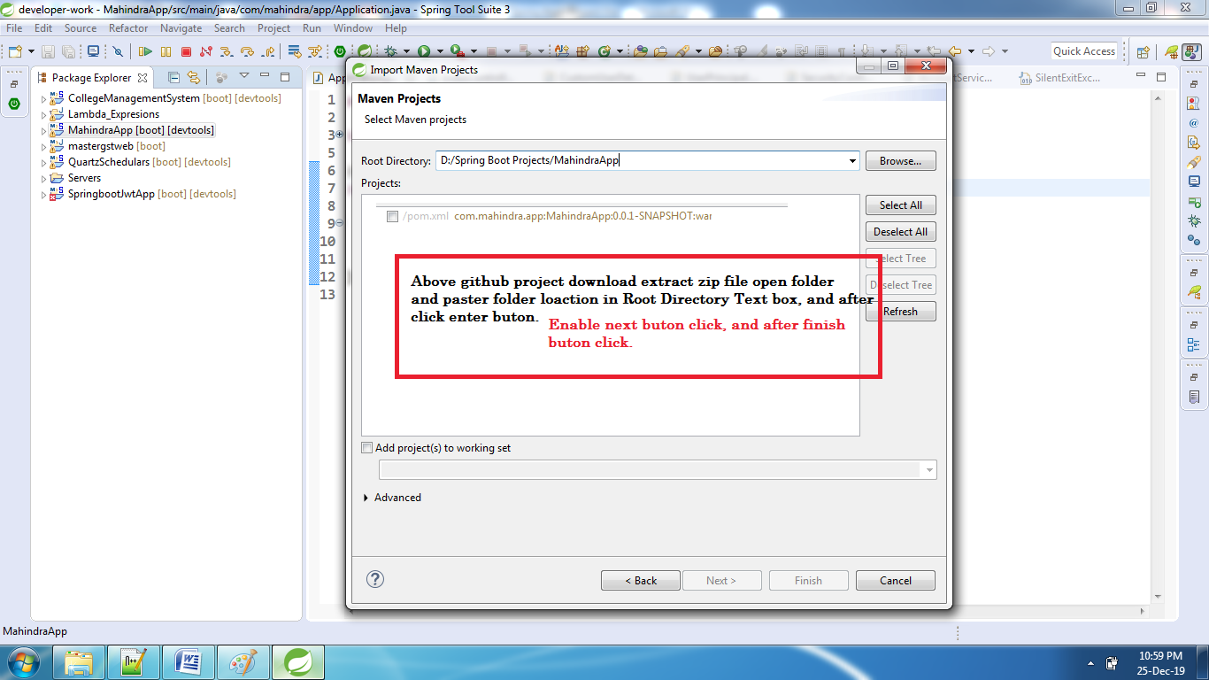

**project import successfully....**

**wait some time(project dependent jars download) and after any errors we can see below steps we can follow, if no errors came, dont follow below steps.**

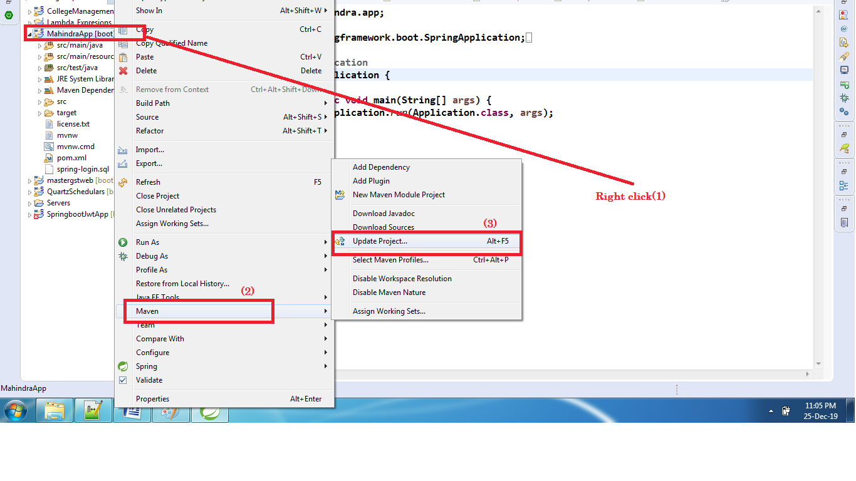

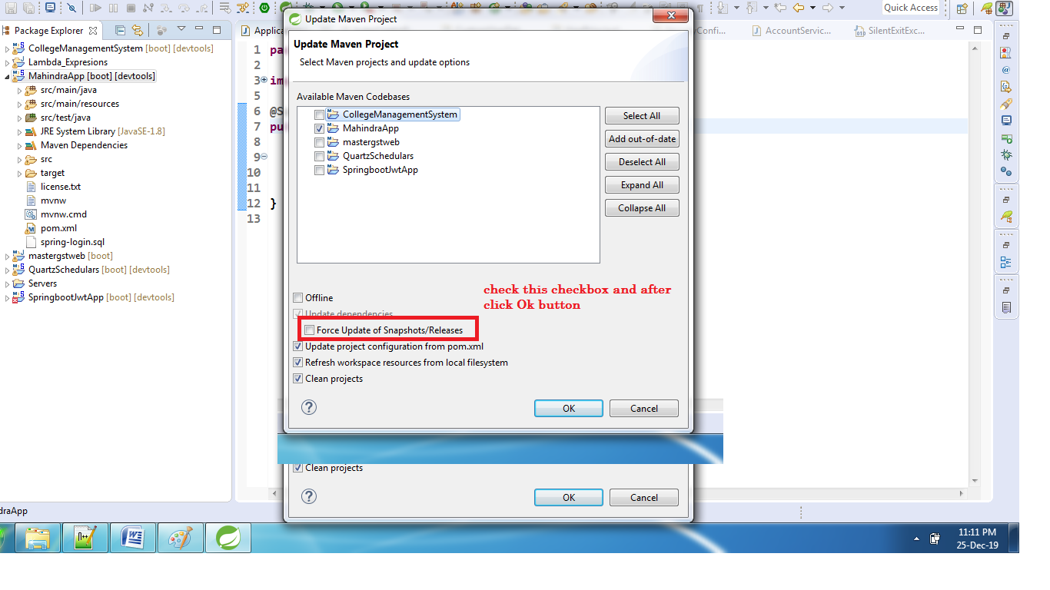

**Above steps we can follow project setup complete.**

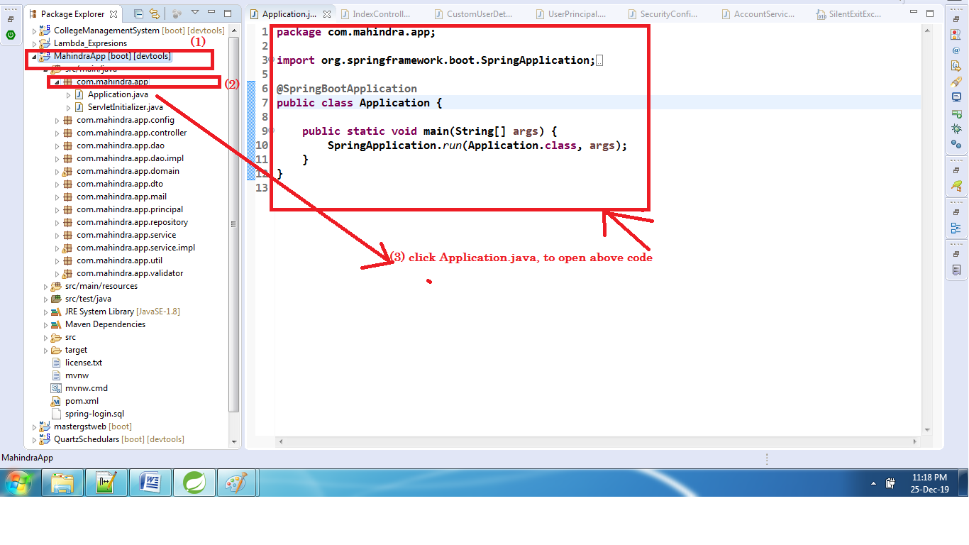

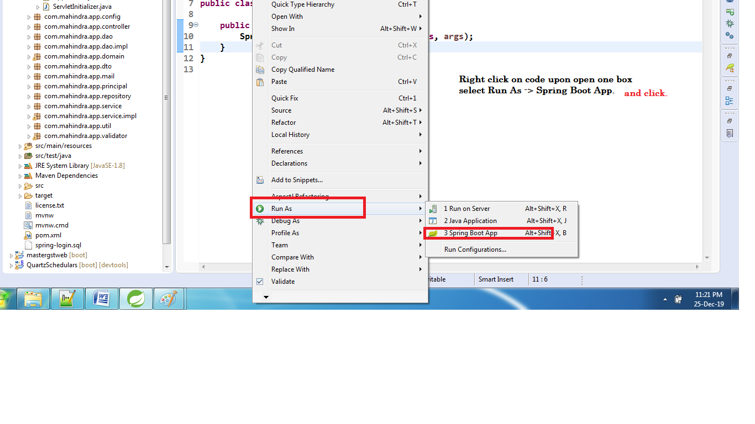

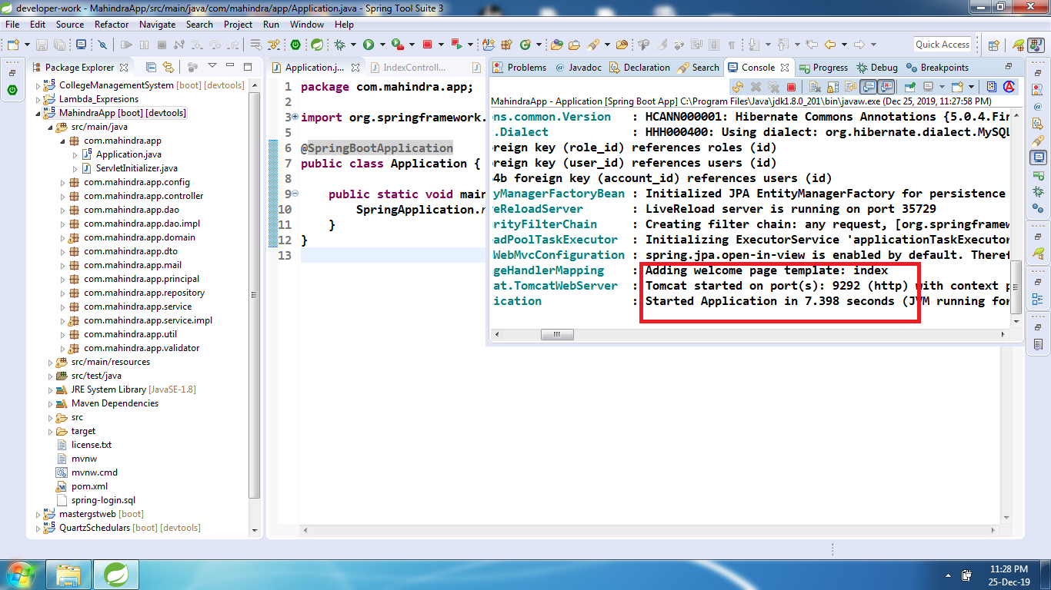

**This document we can follow Project run complete.**

**And After open chrome browser and type below link**

**http:localhost:9292/**

**to open project login page.**